Triple port memories are the ones which have three ports to access the memory cells.

With the help of these three ports, triple port memories can have access to three different

addresses simultaneously.

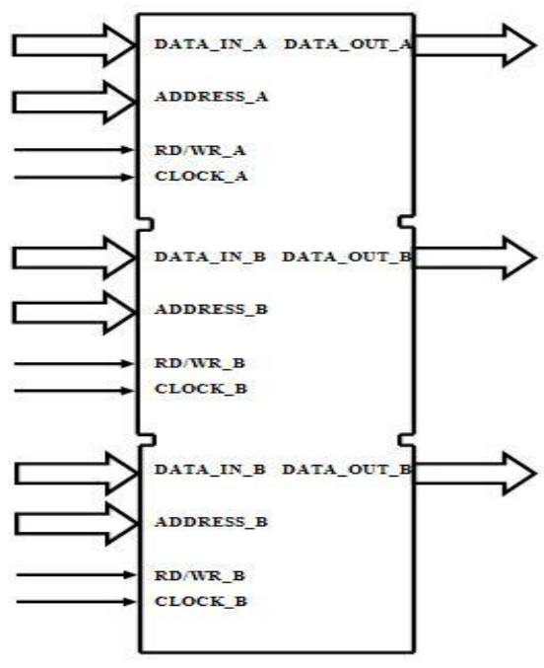

BASIC MEMORY CELL

Basic memory cell is the building block of the RAM cell array used to store the information which is used by the applications or the devices which are using RAM. Basic memory cell consists of a latch which is used to store the one bit data and the input and output circuitry which is used to store and access the data when required by the external devices which are using the memory.

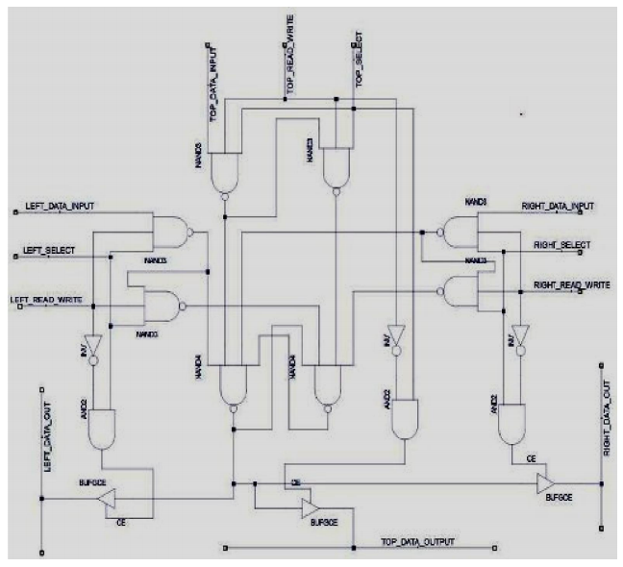

1. Read Operation: The read operation of basic memory cell is quite simple compared to the write operation. For understanding point of view, let’s take read operation from left port. When a read operation is desired the read/write signal of left port is kept at low level suggesting read operation. The left_select line is kept at high level to select the left port. Now the inversion of read/write and lef signal is given to and gate which will produce a high output as both the inputs are output circuitry which is used to store and access the data when required by the external devices which are using the memory.

The working of Basic Memory Cell can be described in two parts, first one is the read operation and the second is the write operation, which are described below.The read operation of basic memory cell is quite simple compared to the write operation. For understanding point of view, let’s take read operation from left port. When a read operation is desired the read/write signal of left port is kept at low level suggesting read operation. The left_select line is kept at high level to select the left port. Now the inversion of read/write and lef and gate which will produce a high output as both the inputs are 12 output circuitry which is used to store and access the data when required by the external The working of Basic Memory Cell can be described in two parts, first one is the read

The read operation of basic memory cell is quite simple as compared to the write operation. For understanding point of view, let’s take read operation from left port. When a read operation is desired the read/write signal of left port is kept at low level suggesting read operation. The left_select line is kept at high level to select the left port. Now the inversion of read/write and left_select and gate which will produce a high output as both the inputs are Triple Port RAM 13 at high level. The output of this and gate will fed to the control signal of a buffer which will pass the input to output if the control signal is high. The input of buffer is connected to output of the storage element, the latch. As the high signal is inserted on the control pin then the bit stored into letch will be taken as output of buffer and in this manner the read operation is being carried out.

2. Write operation: Write operation of the basic memory cell is more complex as compared to read operation as the signals from other ports also have significance. It should be kept in mind that only one write operation can be carried out by any one of three ports at a given time. If multiple write operation are tried then collision will occur and data will be corrupted. Let’s take example by carrying out write operation using left port. When data ‘1’ is written then output of first nand gate is low while the output of second nand gate will be high and output of other nand gates of top and right port will be zero as their read/write signal will be low and data ‘1’ will written into latch. Same case will be for writing ‘0’ but in that case output of the nand gated of left port will be inverted from the previous case.

So, by using a latch for storage and applying a suitable circuitry to read and write from it, a basic memory cell is formed which has three ports to carry out read an 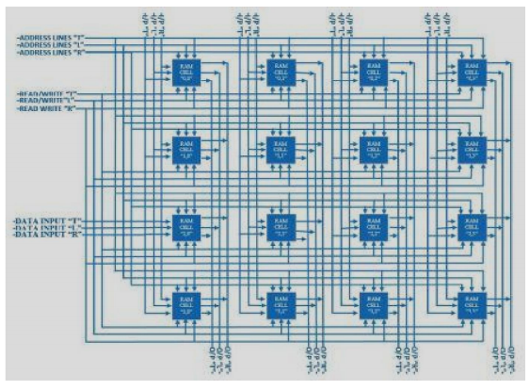d write operations.